How to improve hash power performance
Before improving hash power performance, please check if your miner’s PSU need to be upgraded.

How to check if the PSU of your miner need to be upgraded?

1、Download the Manage tool “InnoMonitor v1.0.4_special”
InnoMonitor v1.0.4_special:
https://drive.google.com/open?id=1yP2Q_XVP06cBAnAM1eZdAGqmTet947Hu

2、Double Click to open the “InnoMonitor” after decompress the “InnoMonitor v1.0.4_special” you download before.
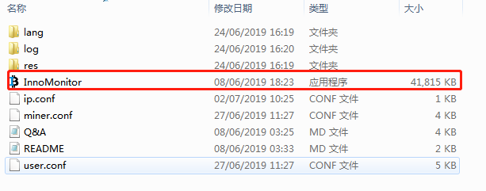
3、Use “Ctrl+F1” to open the setting interface, then select the language to English as below
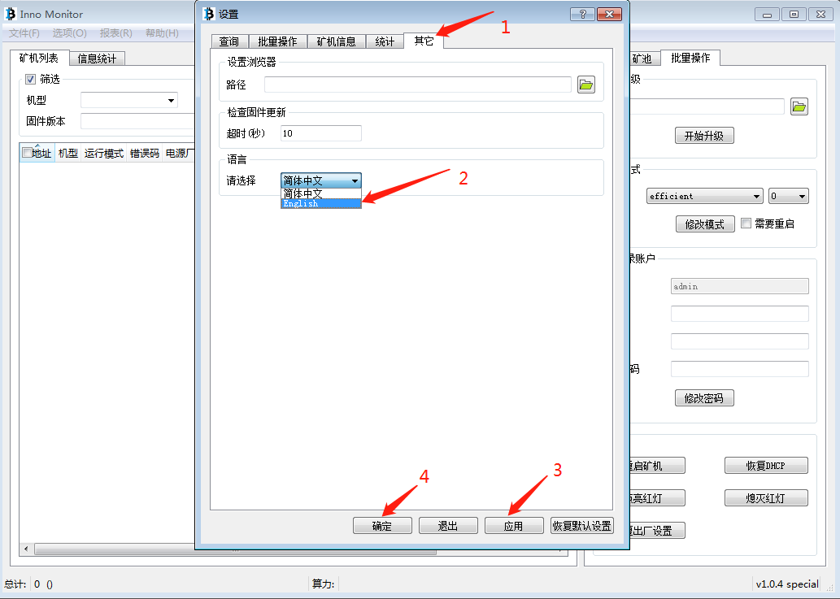
4、Scan all the info of the miner by the Inno Monitor
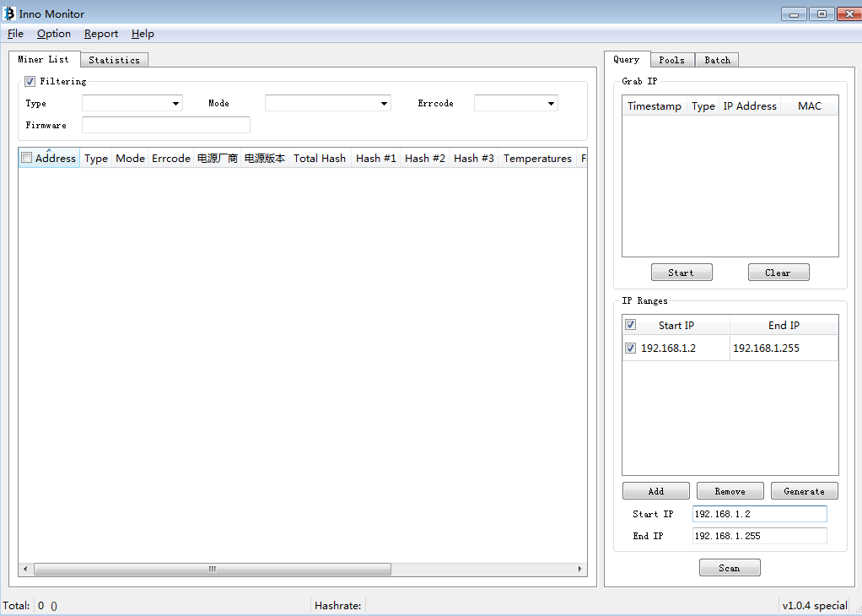
PSU
Versionctory
If the PSU supplier is GP and the PSU Version is less than 7.66(eg.0.66/2.66/ 5.66), your miner need upgrade the firmware.
PSU
Supplierctory
1、input the IP range of your miner
3、click “scan”
2、click “add”

Only when the PSU supplier is GP and the PSU Version is less than 7.66(eg.0.66/2.66/ 5.66), your miner need upgrade the firmware.

How to upgrade PSU firmware?
- Download firmware 20190621 (PSU upgrade)
T2TS-26T Firmware:
https://drive.google.com/open?id=173x_HWb4M3k64LMhkAyp7mLWP9_Ogs2z
T2TZ-30T Firmware:
https://drive.google.com/open?id=1hzwRkKP2YNkEGIQDe5fE3NYuGWy6P8rV

2、Start upgrading
After you select the miner which need upgrading you can make the upgrade in batch by the Inno Monitor as below
a. Click the “Batch”
b. Click the to choose the firmware
c. Choose the firmware and click the “Open”
d. Click the “Start upgrading”

Note:
Please make sure the network and the power supply is stable and don’t make any kind of operation until 15 mins later when the Inno Monitor shows the upgrade is success.
Then scan the miner again to make sure all the miners have successfully been upgraded to PSU version 7.66.
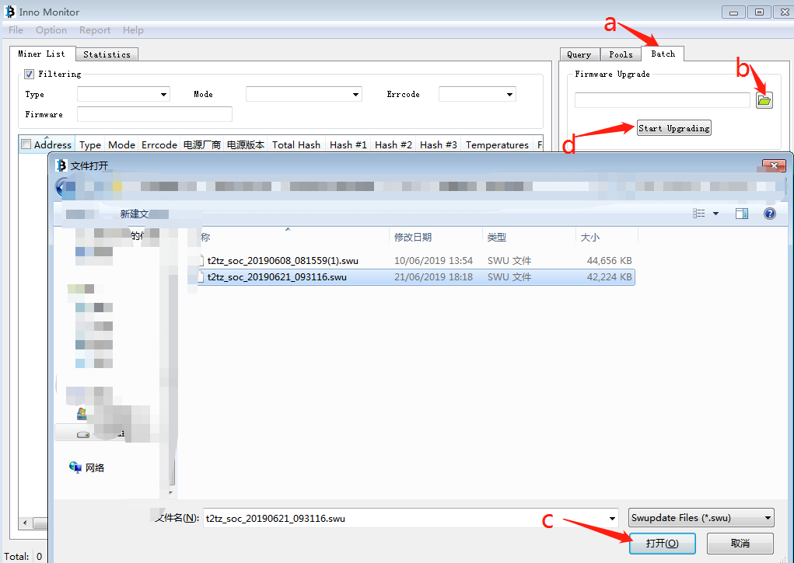

How to use 20190705 firmware to improve hash power performance？
Download 20190705 firmware：
T2TS-26T：
http://www.innosilicon.shop.cn/download/t2ts_soc_20190705_023516.swu
T2TZ-30T：
http://www.innosilicon.shop.cn/download/t2tz_soc_20190705_023308.swu

- Scan all the miners with management tool “InnoMonitor v1.0.4_special”
1、input the IP range of your miner
2、click “add”
3、click “scan”

- Upgrade the miners in Batch
a. Click the “Batch”
b. Click the to choose the firmware
c. Choose the firmware and click the “Open”
d. Click the “Start upgrading”
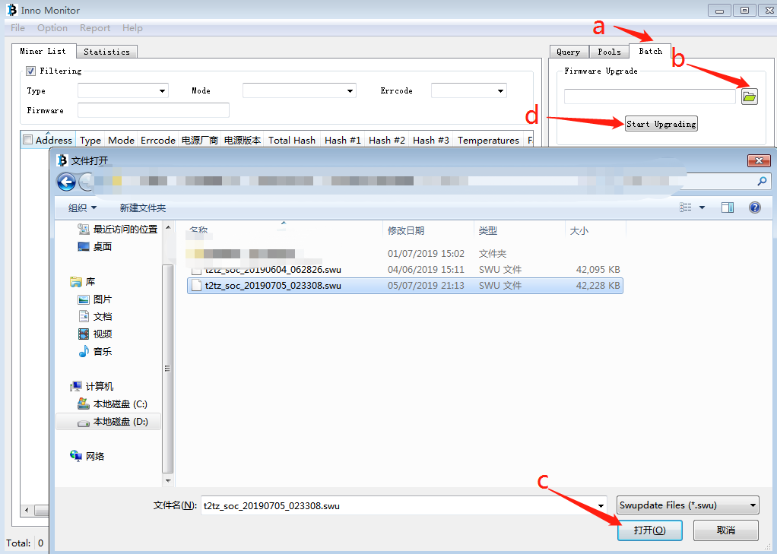
- When the upgrade is completed, scan all the miners again to check if the firmware version is 20190705. If the firmware is still the old version, please try again to upgrade those unsuccessfully upgraded miners. 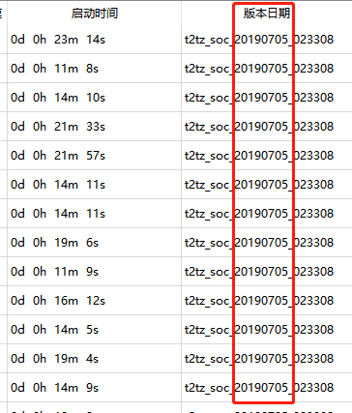
- After you confirm every miner is successfully upgraded to version 20190705, switch the running mode to “Performance”.
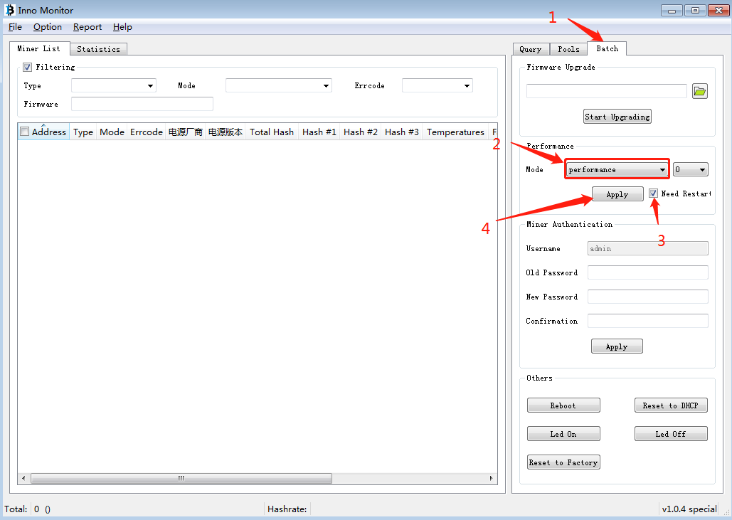

5、When all the above operations are completed, wait for the machine to stably run for 2 hours to improve the hash power.

Any question please contact: miner_support@innosilicon.shop.cn

